**AWS PROJECT**

**Dashboards**

**1. AWS Login screen with username**

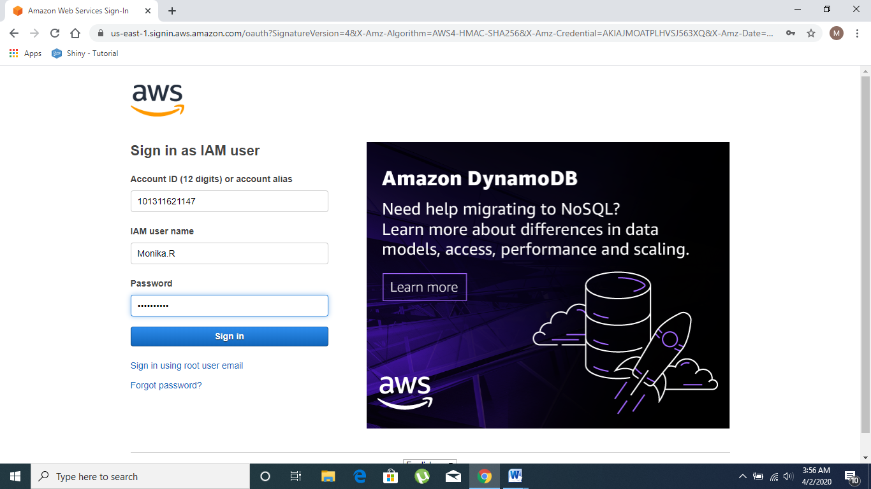

**2. EC2 Dashboard**

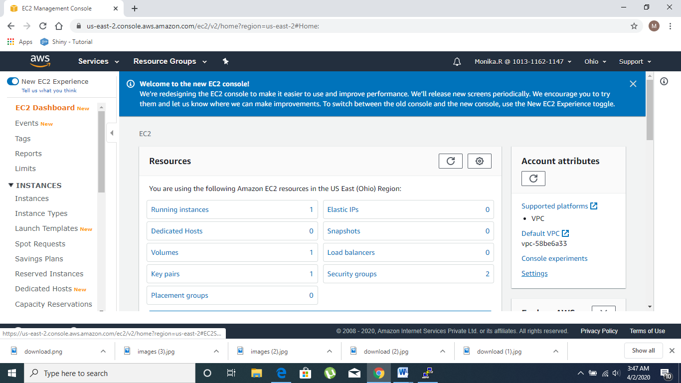

**3. S3 Dashboard**

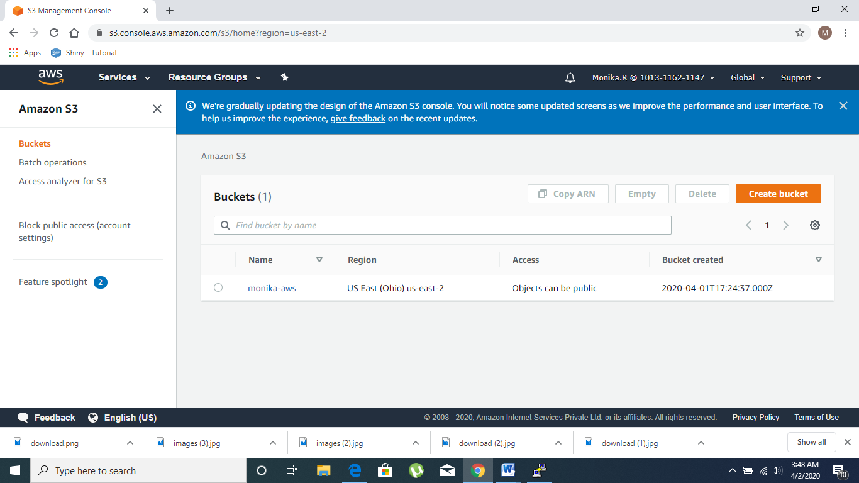

**4. Rekognition Dashboard**

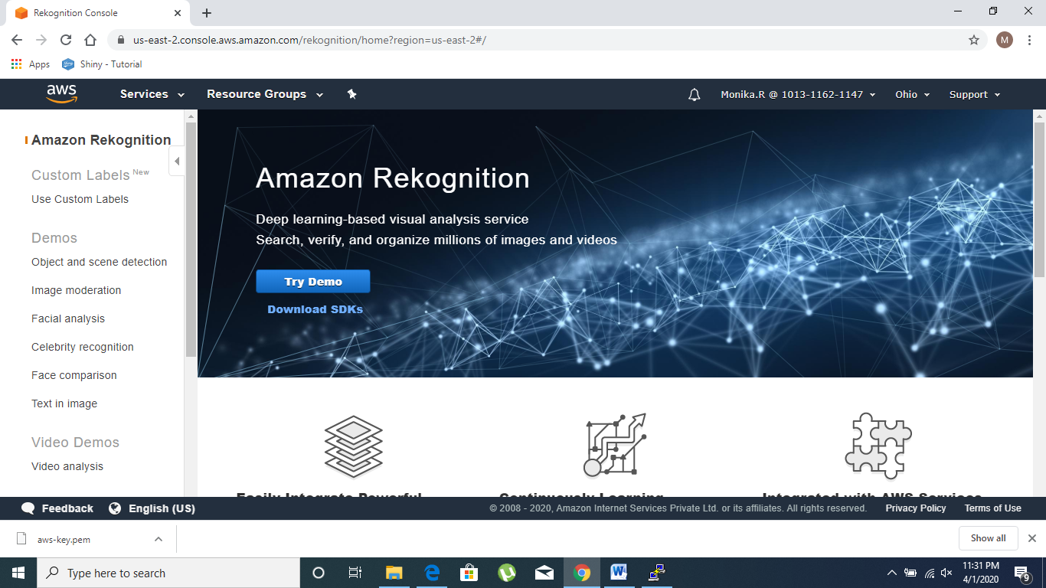

**EC2**

**1. Choosing an AMI**

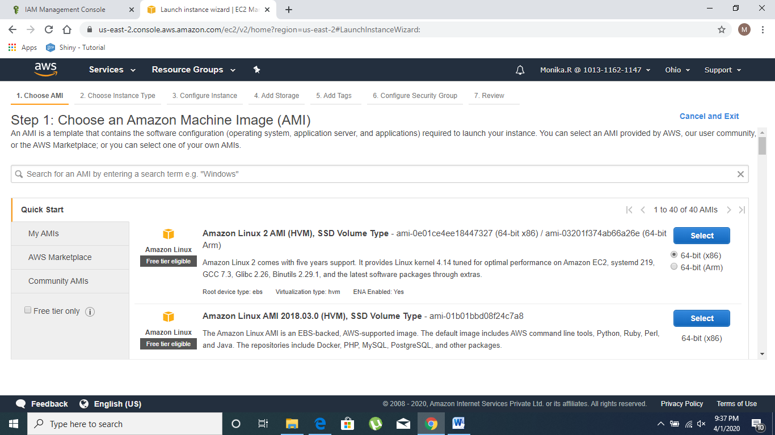

**2. Choosing an Instance Type**

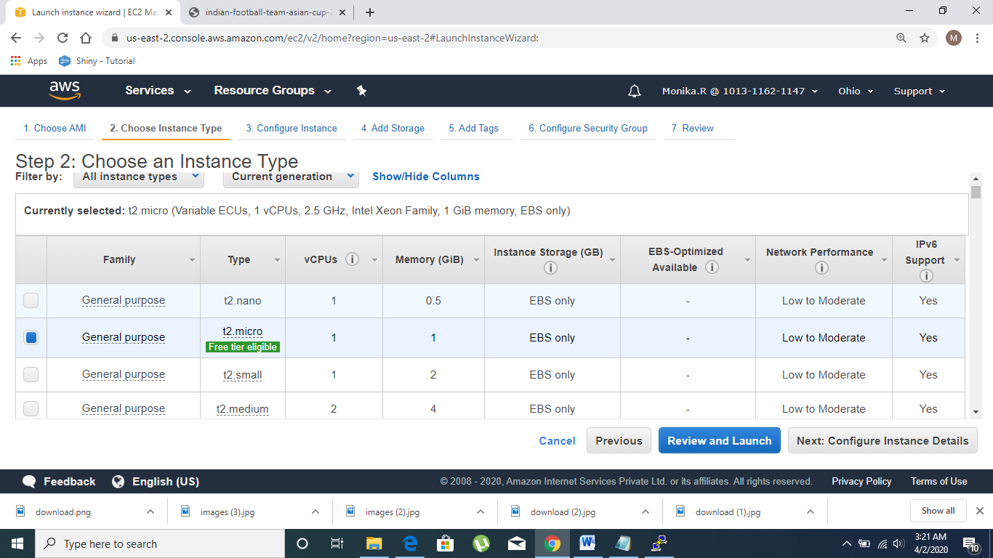

**3. Adding Storage**

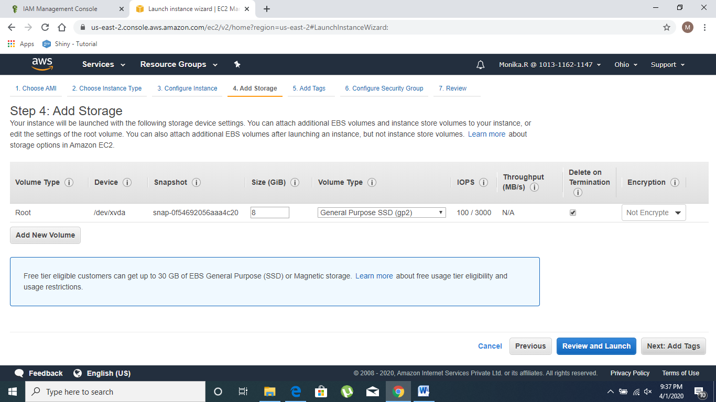

**4. Conﬁguring Security Group**

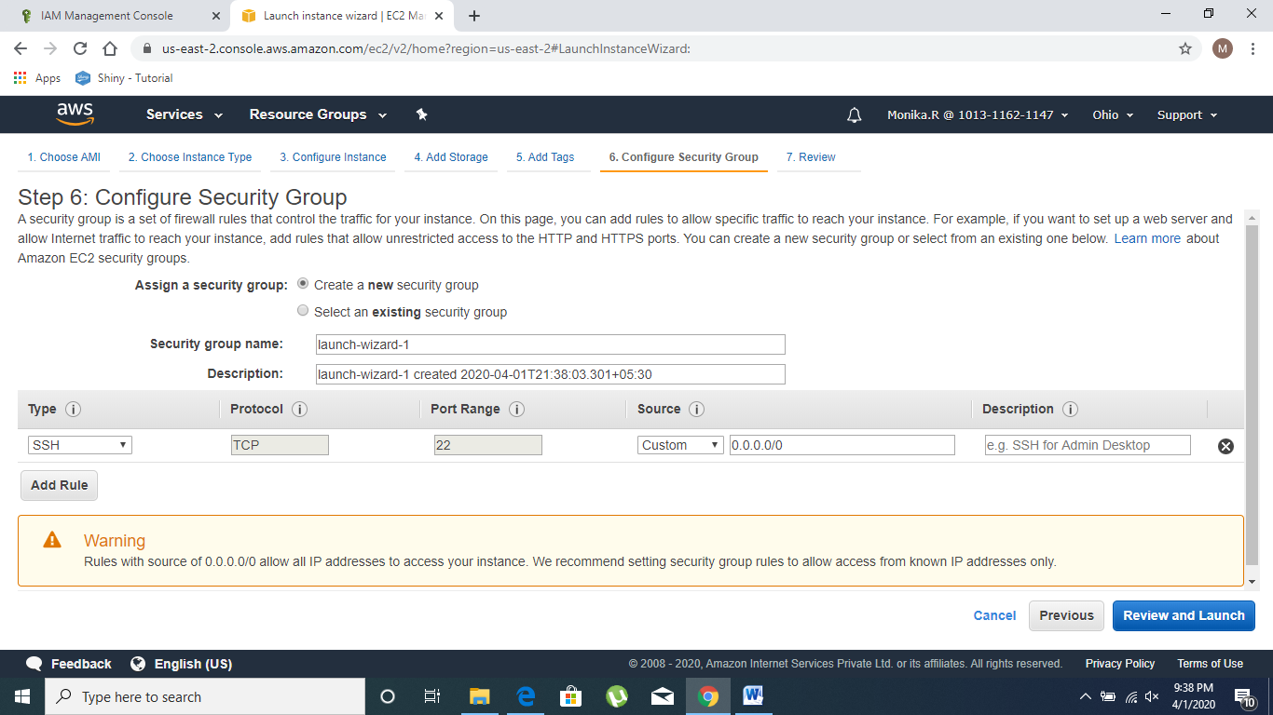

**5. Key Pair Download**

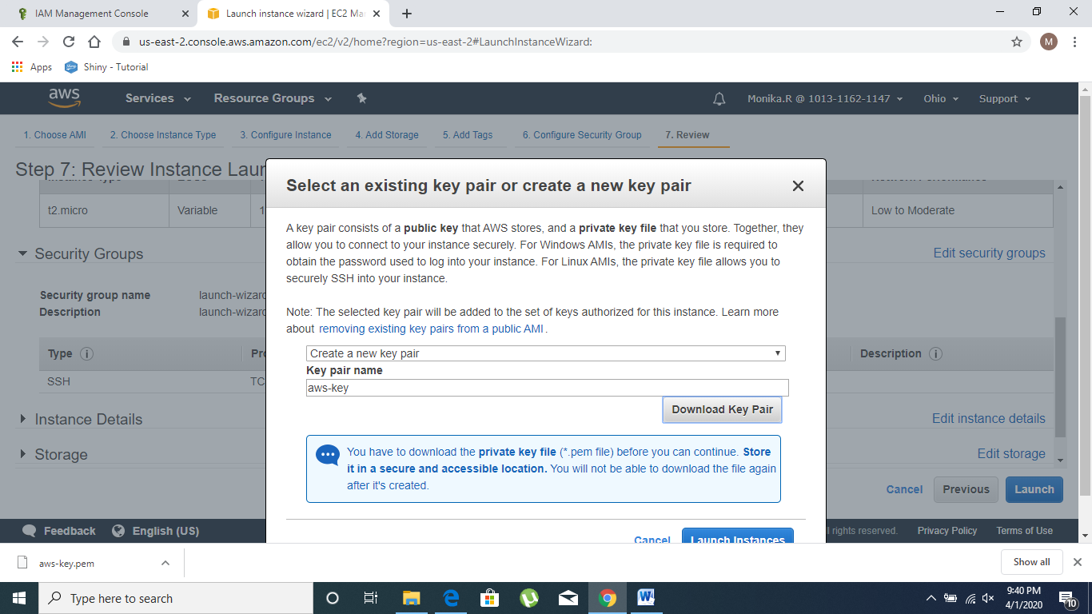

**6. PuTTYgen conversion from pem to ppk**

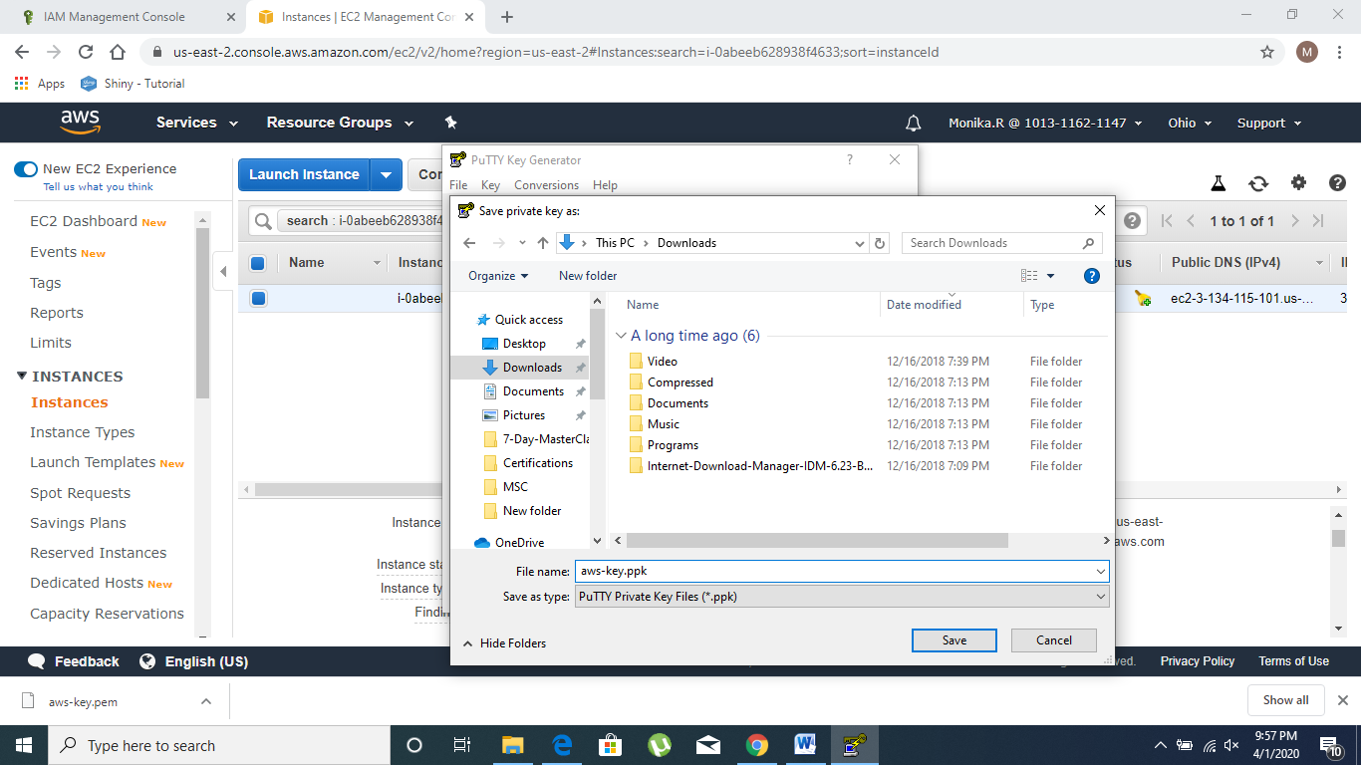

**7. Logged in EC2 black screen**

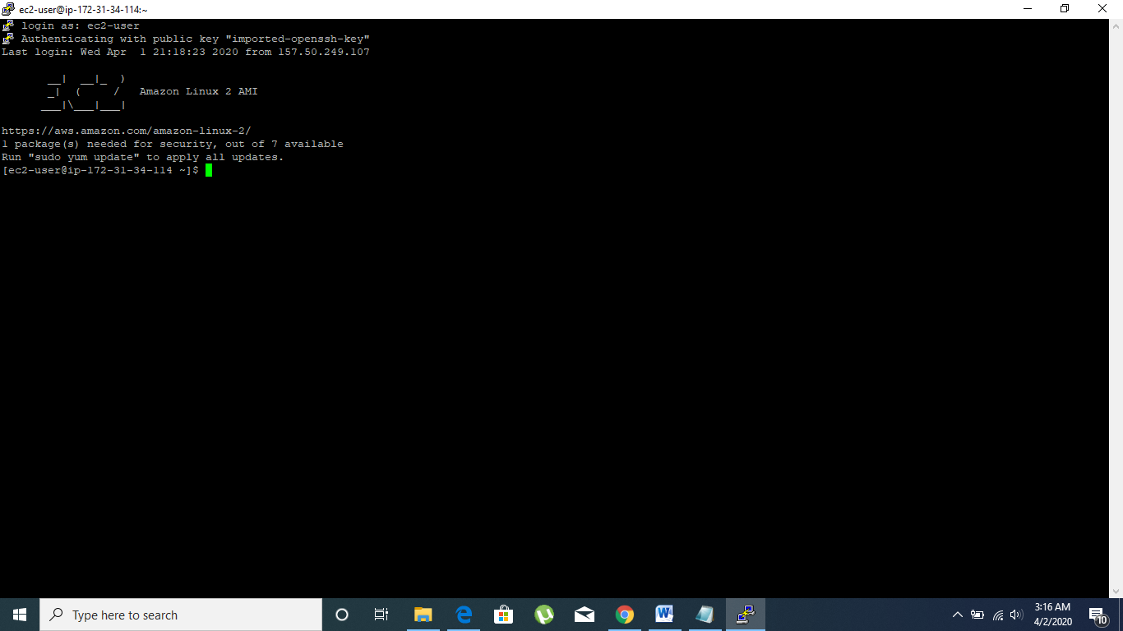

**S3**

**1. Creating a bucket**

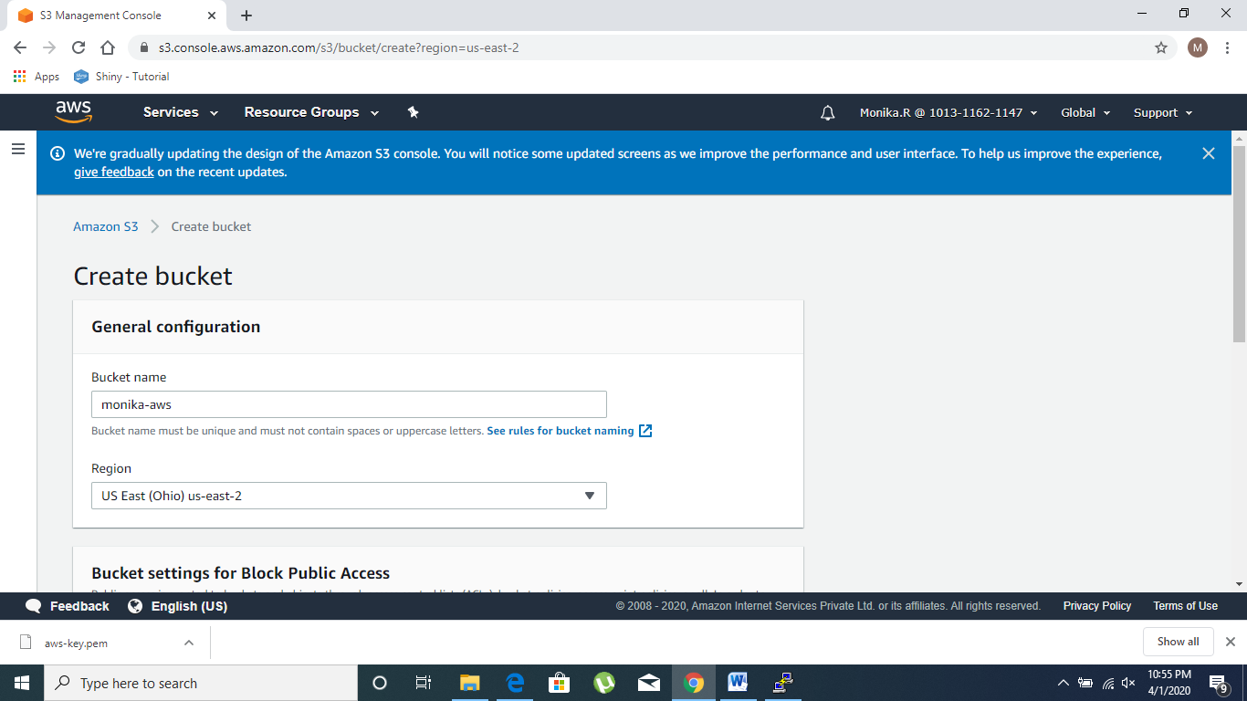

**2. Uploading an Object**

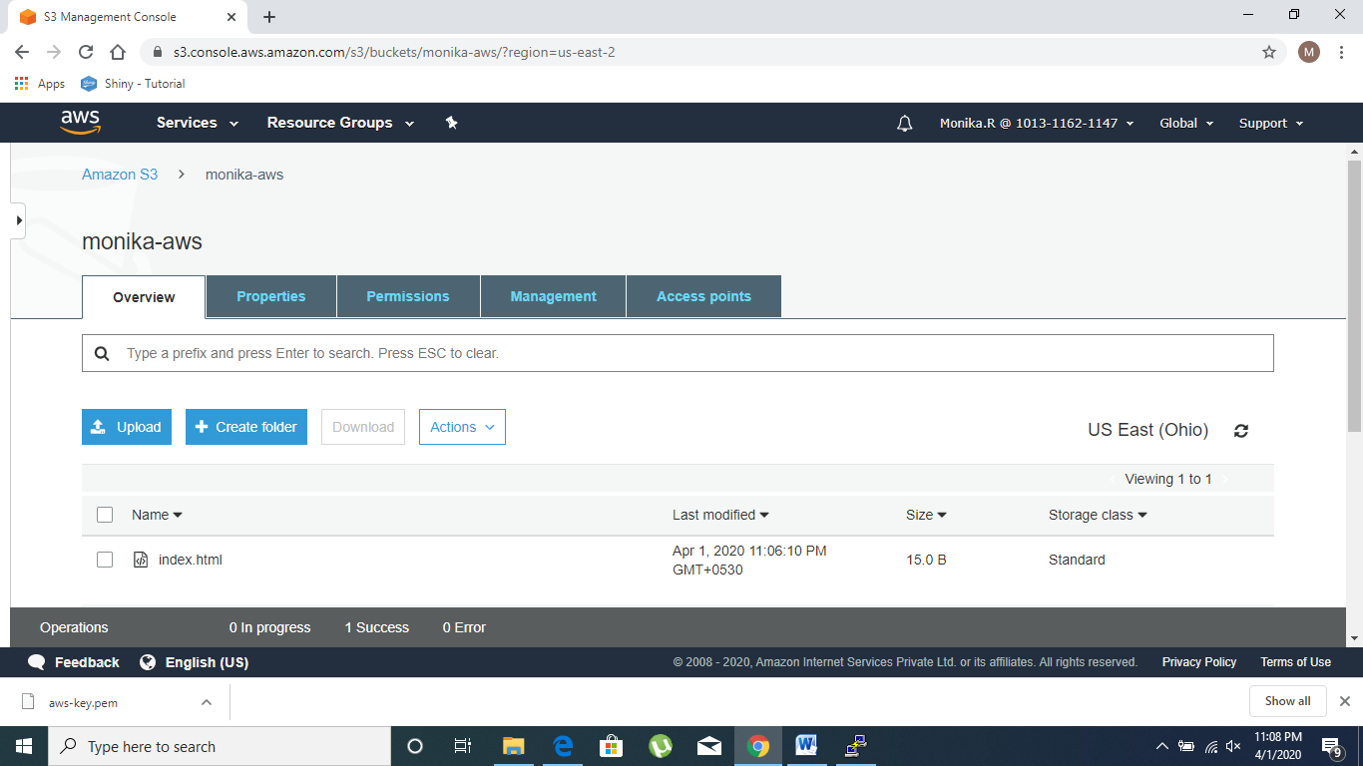

**3. Enabling Static Website**

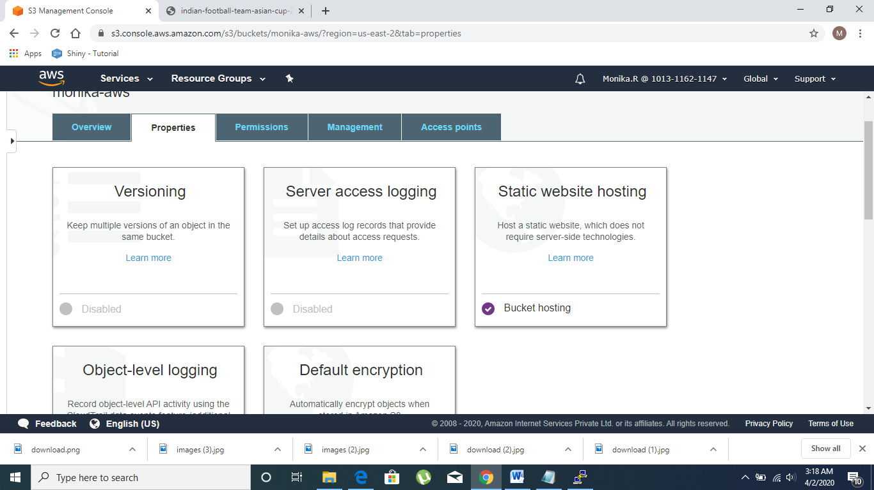

**4. Making the Object Public**

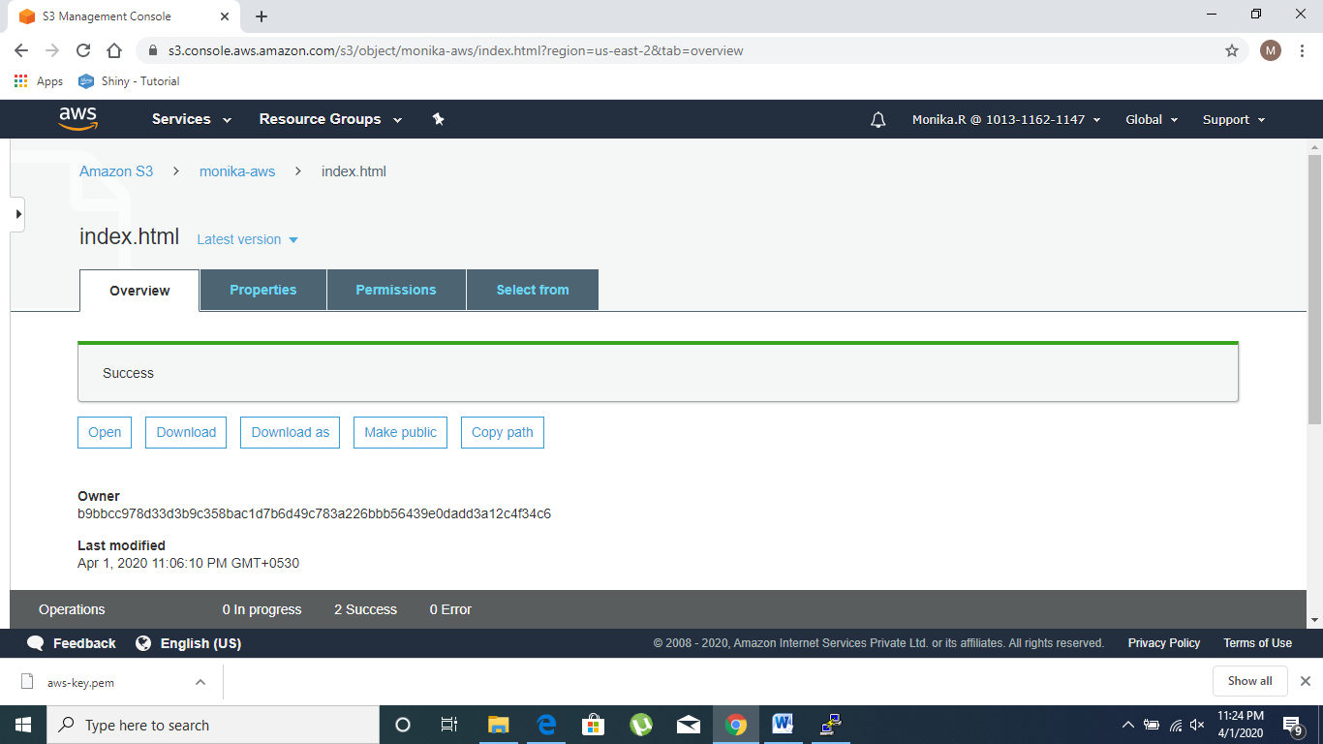

**5. Checking the S3 link on the browser**

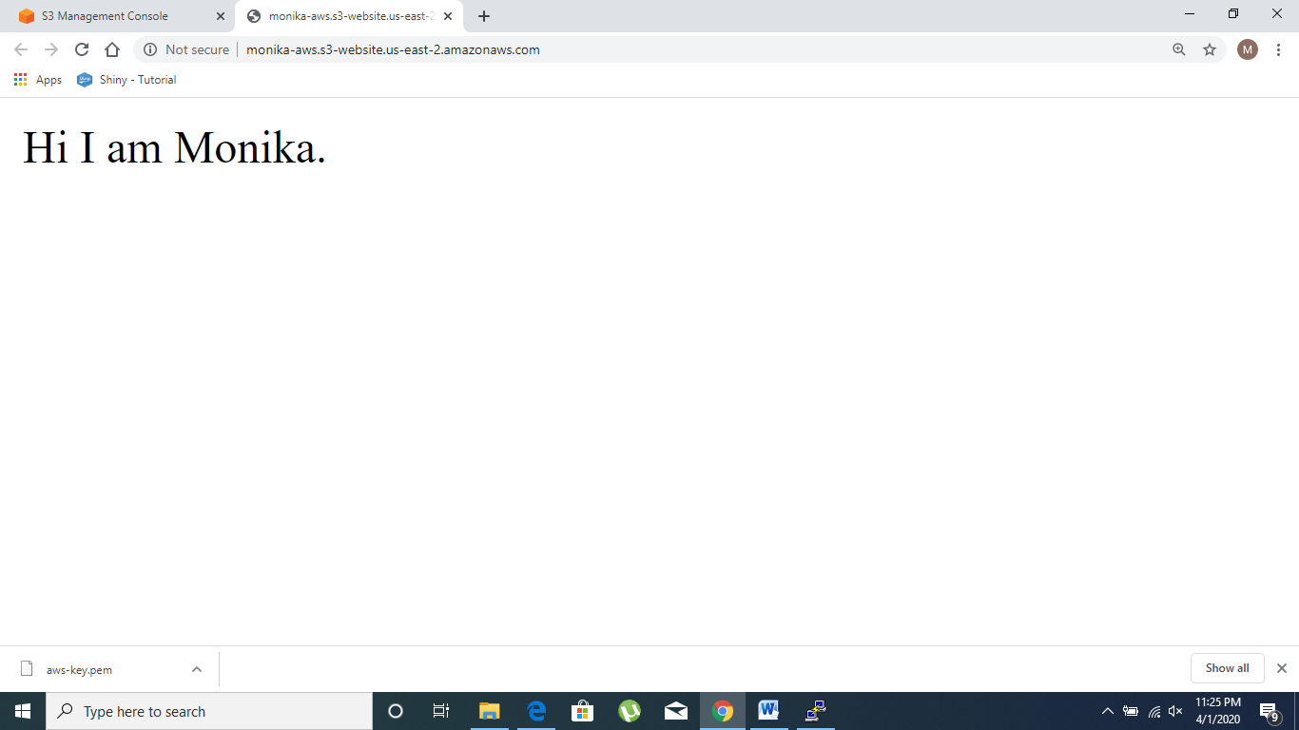

**Rekognition**

**1. Face Detect**

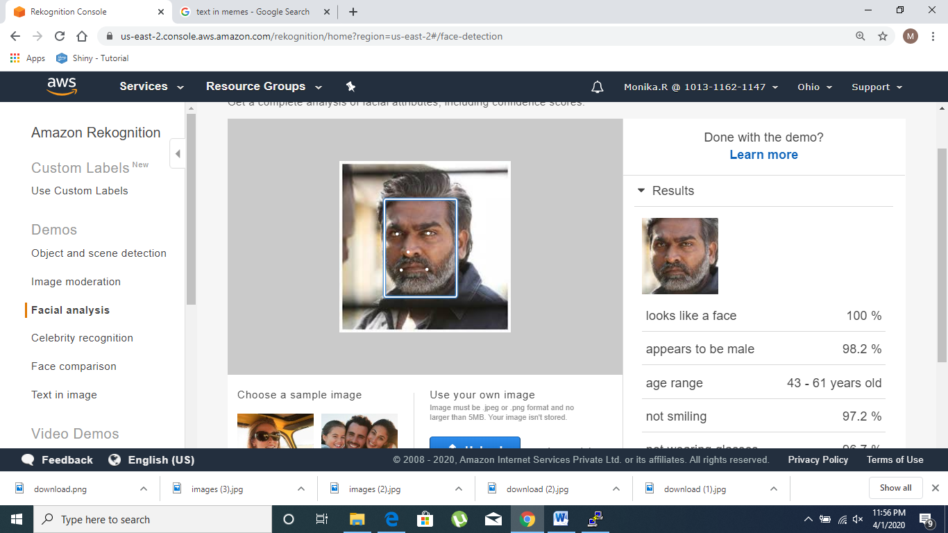

**2. Face Compare**

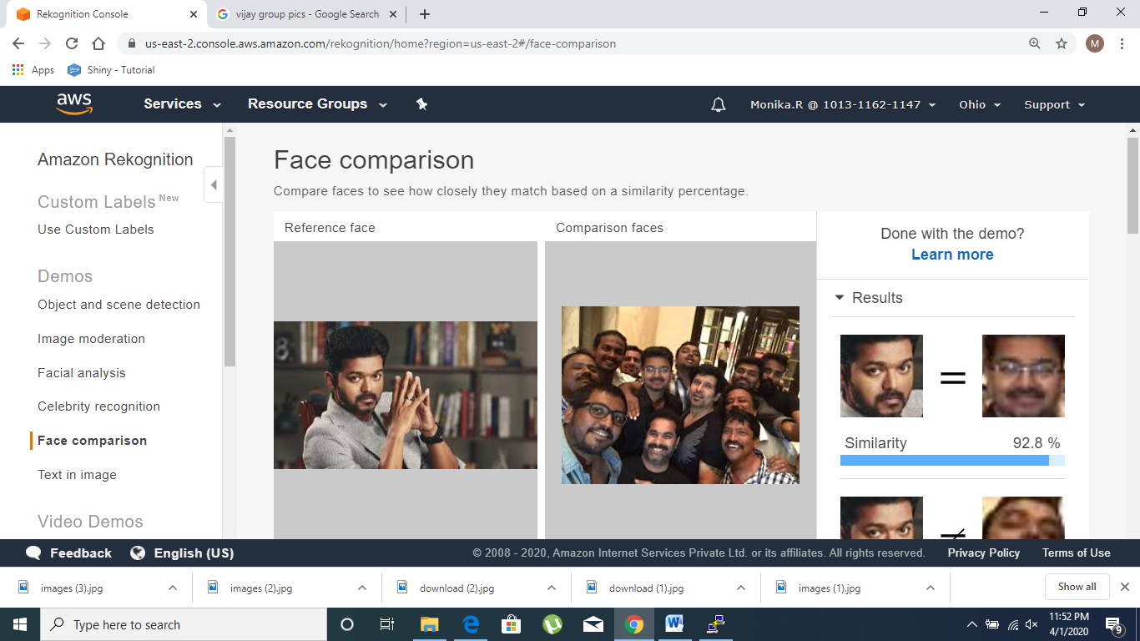

**3. Celebrity Recognition**

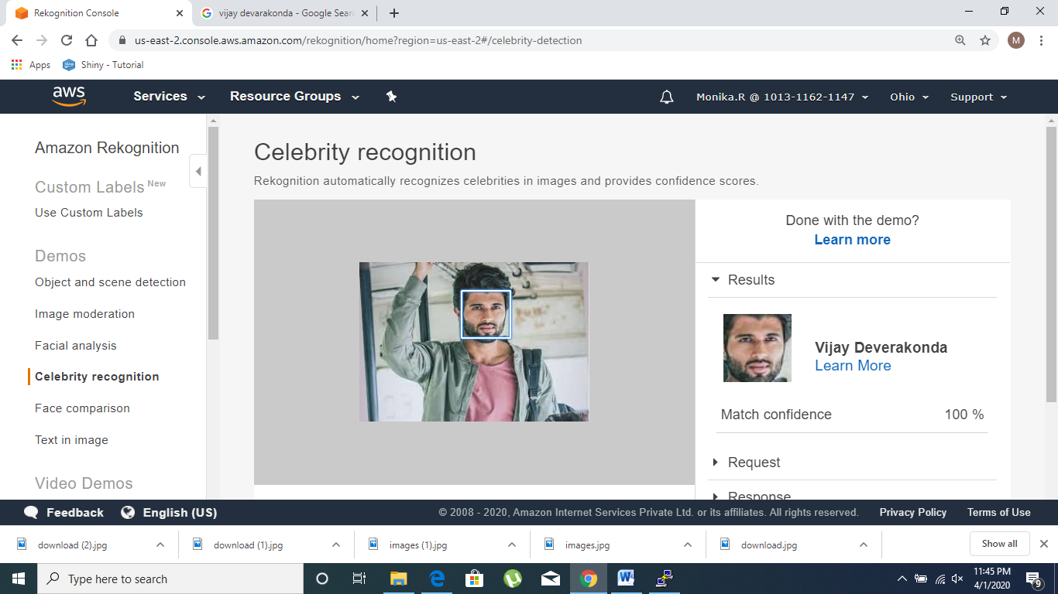

**4. Text in Image**

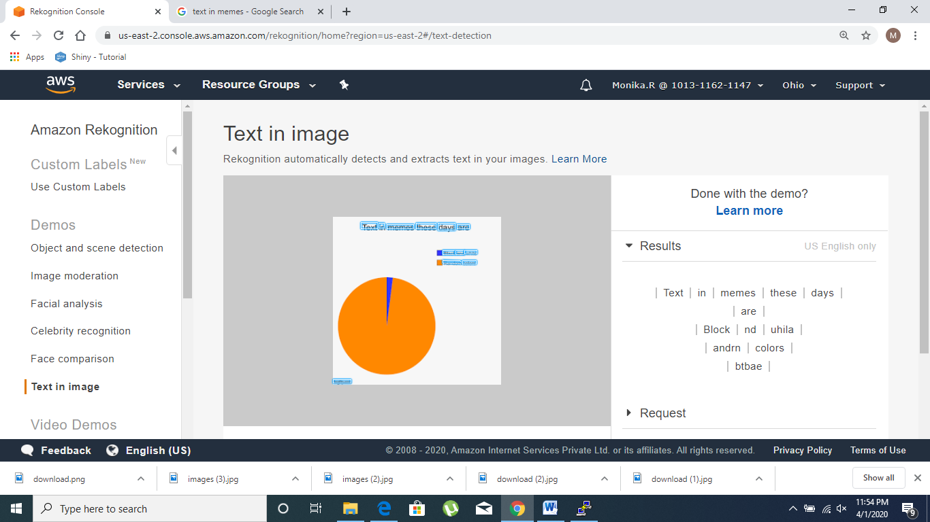

**EC2 & S3**

**1. Installing aws-sdk**

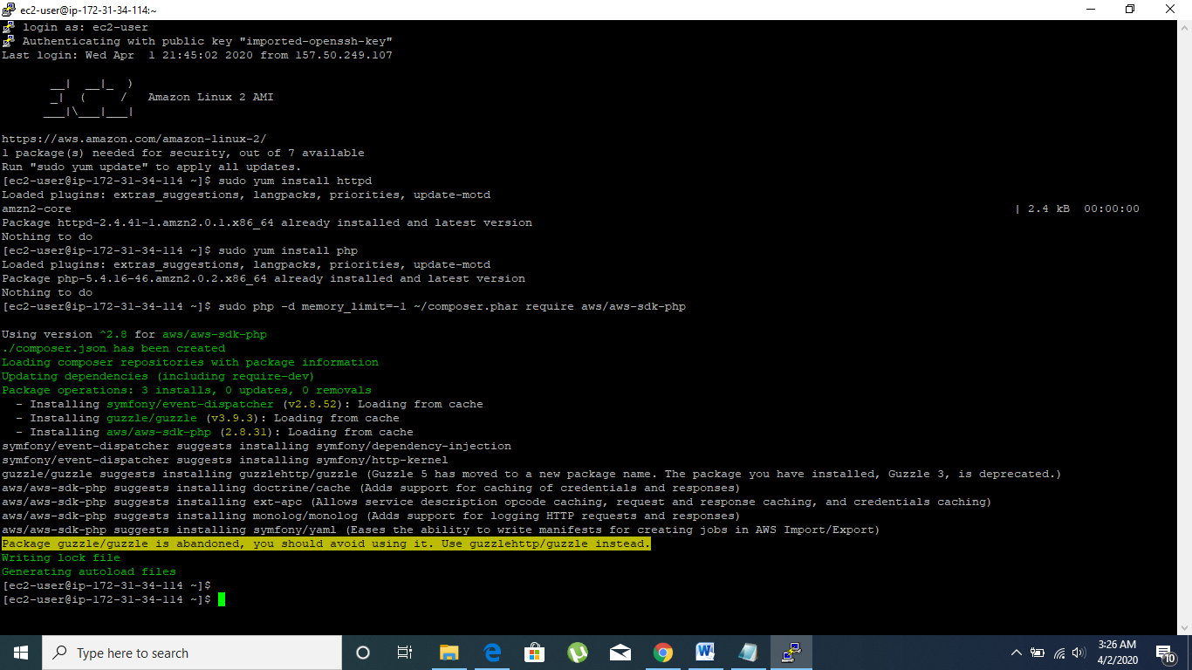

**2. Installing php**

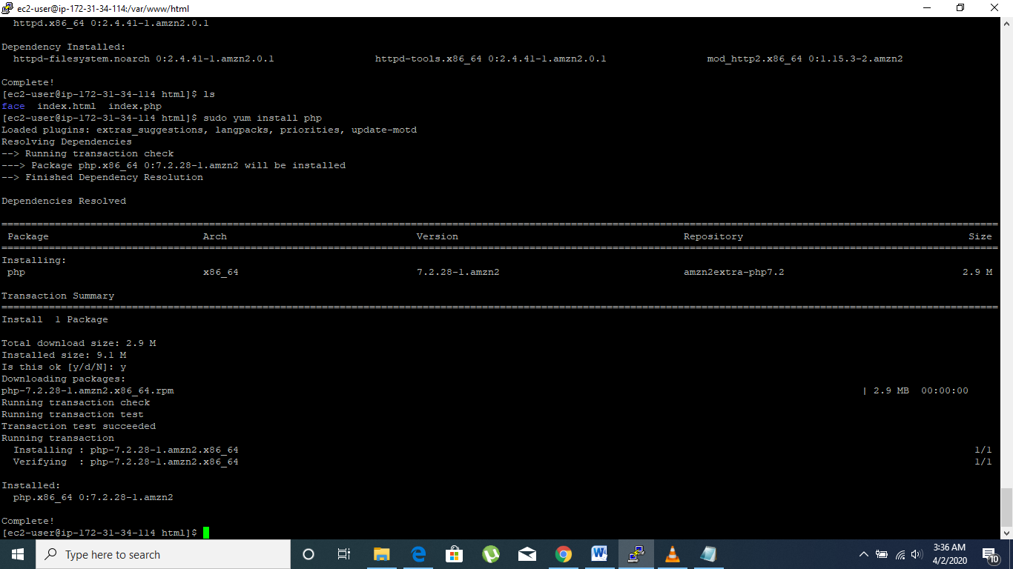

**3. index.php ﬁle code**

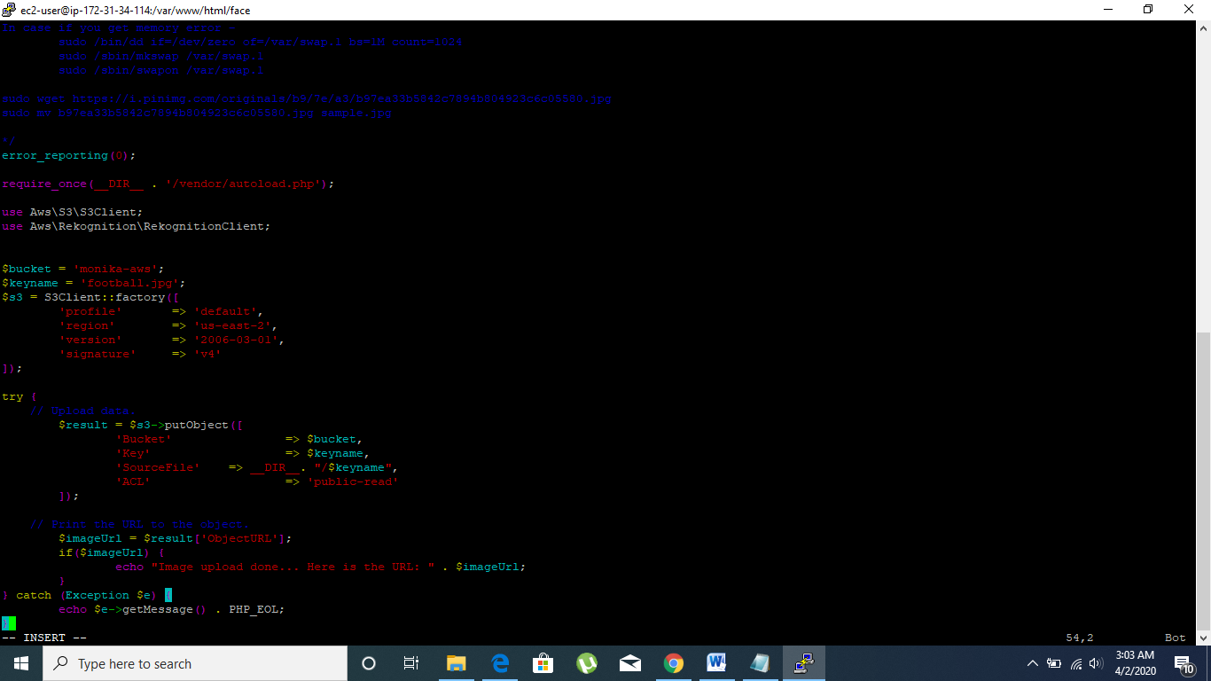

**4. Upload success screenshot**

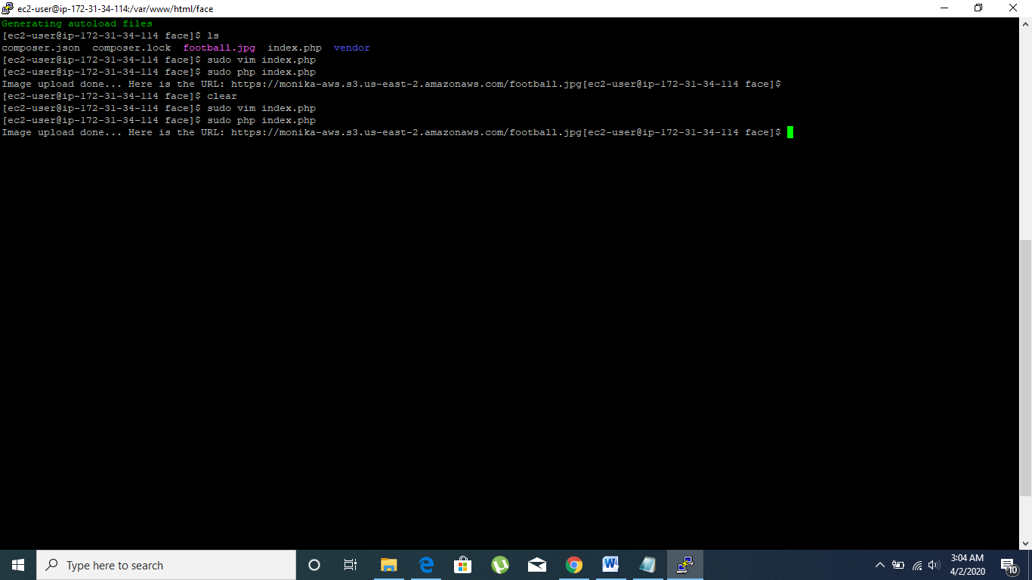

**EC2 & Rekognition**

**1. Face Detect success screenshot**

